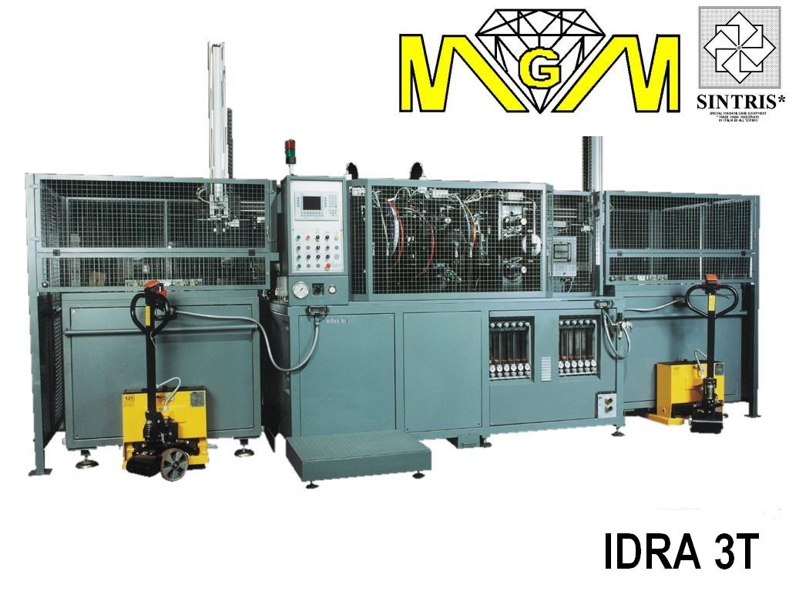

*AUTOMATIC SINTERING MACHINE mod. IDRA 3T, WITH THREE STATIONS, 240 kVA, 42TON.
Main features
• Machine suitable for the continuous production of average/large series of diamond segments.
• Cycle subdivision into three phases / stations:
  ▪ station 1: preheating
  ▪ station 2: sintering
  ▪ station 3: cooling
• The sintering process takes place in a controlled atmosphere in the 3 stations by inlet of inert/reducing gas. During the transport between the stations the mould is protected by a “shower” of the same gas.
• Temperature control with thermo-couple automatically inserted in the center of the mould.
• Type K thermo-couple for operating temperatures up to 1000°C.
• Evacuation system and smoke filtering with water filter.
• Preheating, sintering and cooling times are the same.
• Control program with cycles divided into 12 steps. Each step includes:
  ▪ temperature
  ▪ pressure
  ▪ max. power limit
  ▪ heating time
  ▪ holding time
• From 18 up to 64 mould unloading and loading magazine.
• Automatic mould feeding from mould magazine.
• 18 special aluminium frames.
• Process data visualisation (set and real) and alarms.
• Machine complies with EEC regulations.
Options
• Analogic outlet for variable process recording.
• Pyrometer 350-1300°C to be used alternatively to the thermo-couple.
• Height segment reading during sintering process (linear transducer on cylinder, resolution of 0.01 mm)
• Data acquisition system on external PC.
• Barcode reading system for automatic selection of sintering cycle according to product in aluminium frame, including labelling machine.
• 18/36 moulds loading/unloading magazine.
• Aluminium frames.
• Electrodes in graphite.
• Graphite plates.
• Graphite moulds.
• Thermo-couples.
• Prearrangement for modem installation for remote assistance.
Technical Data
• Max. sintering area | 110 cm² (850°C 350kg/cm²)
• Approx. sintering cycle time | 8 minuti
• Productivity | 600-650 segm/h (40x2.8mm - 90segm/mould)
 | 270-310 segm/h (24x10mm - 44segm/mould)
• Loading and unloading magazine | n.18 moulds
• Power supply | 380 / 400V 3phs 50Hz
• Max. power consumption | 2 x [120 kVA - (175 A)]
• Transformers | 2 x 120 kVA
• Compression force on the 3 stations (adjustable) | 3000 - 42000 kg
• Electrode dimensions | 150 x 160x60(h)mm
• Plate dimensions | 150 x 160x65(h)mm
• Aluminium frames dimensions | 193 x 158mm
• Max. mould height | 110mm
• Gas consumption | 15 – 30 l/min N₂/Ar₂ (max. 5% H₂)
• Air consumption (filtered) | 10 l/min 6 bar
• Industrial water consumption | 100-120 l/min 2–6 bar 10-20°C
• Colour | Coiche
• Overall size (approx.) | 2000x3500x2500(h) mm
• Weight (approx.) | 4000 kg

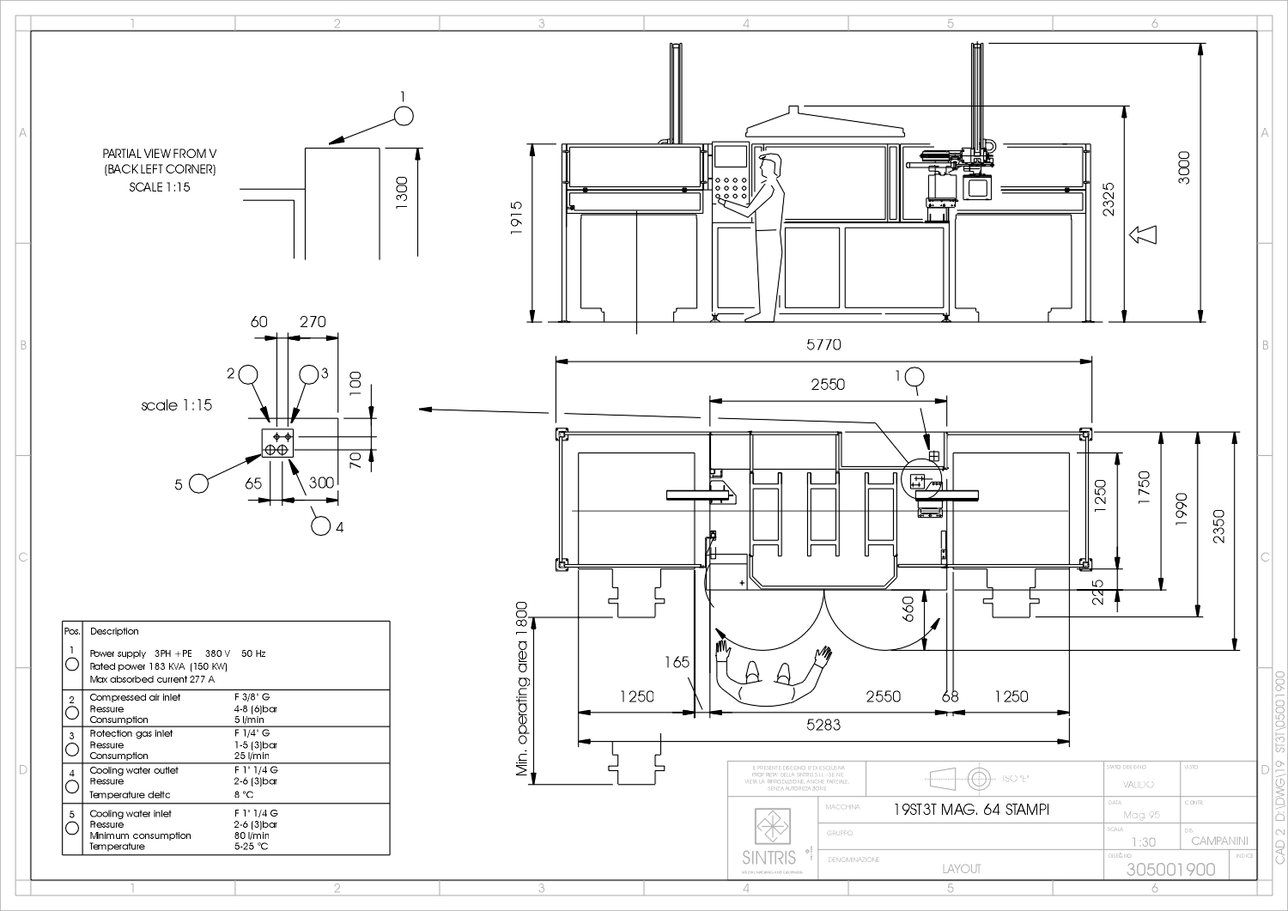

* MGM reserve itself the right to change the characteristics described in this document without previous notice.

