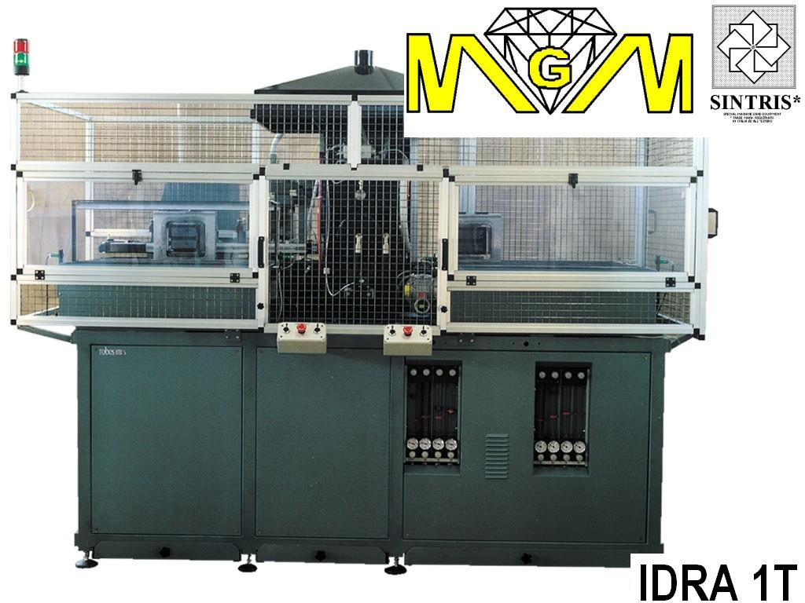

*AUTOMATIC SINTERING MACHINE mod. IDRA 1T, WITH ONE STATION, 120 kVA, 42TON.
Main features
• Machine suitable for the continuous production of average/large series of diamond segments.
• The sintering process takes place in a controlled atmosphere in the sintering stations by inlet of inert/reducing gas in the sintering station.
• Temperature control with thermo-couple automatically inserted in the center of the mould.
• Type K thermo-couple for operating temperatures up to 1000°C.
• Evacuation system and smoke filtering with water filter.
• Control program with cycles divided into 12 steps. Each step includes:
  ▪ temperature
  ▪ pressure
  ▪ max. power limit
  ▪ heating time
  ▪ holding time
• Memory allows for storing of up to 120 sintering programs.
• 18 mould unloading and loading magazine.
• Automatic mould feeding from mould magazine.
• 18 special aluminium frames.
• process data visualisation (set and real) and alarms.
Options
• Analogic outlet for variable process recording.
• Pyrometer 350-1300°C to be used alternatively to the thermo-couple.
• Height segment reading during sintering process (linear transducer on cylinder, resolution of 0.01 mm) with possible cycle interruption according to feedback. The system allows for pressure control during the liquid phase of sintering.
• Data acquisition system on external PC.
• Barcode reading system for automatic selection of sintering cycle according to product in aluminium frame, including labelling machine.
• 36 moulds loading/unloading magazine.
• Aluminium frames.
• Electrodes in graphite.
• Graphite plates.
• Graphite moulds.
• Thermo-couples.
• Prearrangement for modem installation for remote assistance.
Technical Data
• Max. sintering area | 110 cm² (850°C 350kg/cm²)
• Approx. sintering cycle time | 11 - 12 min.
• Productivity | 400-450 segm/h (40x2.8mm -90segm/mould)
 | 200-220 segm/h (24x10mm - 44segm/mould)
• Loading and unloading magazine | n.18 moulds
• Power supply | 380 / 400V 3phs 50Hz
• Max. power consumption | 120 kVA (175 A)
• Transformer | 120 kVA
• Compression force (adjustable) | 3000 - 42000 kg
• Electrode dimensions | 150 x 160x60(h)mm
• Plate dimensions | 150 x 160x65(h)mm
• Aluminium frames dimensions | 193 x 158mm
• Max. mould height | 110mm
• Gas consumption | 10 – 20 l/min N₂/Ar₂ (max. 5% H₂)
• Air consumption (filtered) | 10 l/min 6 bar
• Industrial water consumption | 60-80 l/min 2–6 bar 10-20°C
• Colour | Choice
• Overall size (approx.) | 2700x2000x2500(h) mm
• Weight (approx.) | 3000 kg

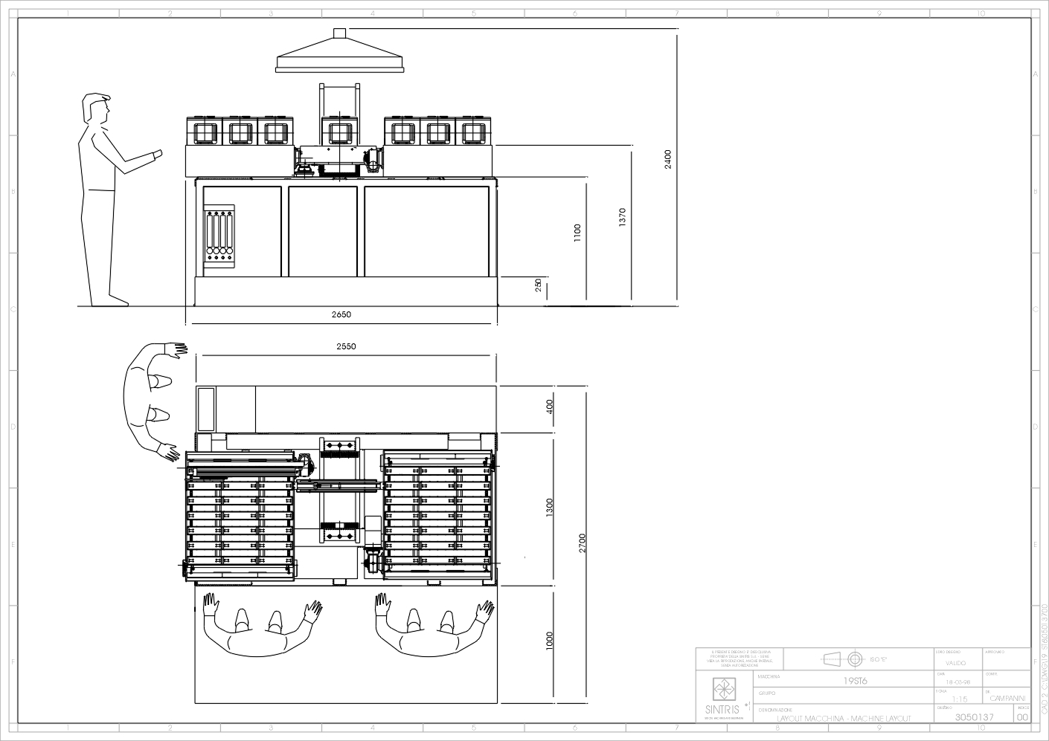

* MGM. reserve itself the right to change the characteristics described in this document without previous notice.

