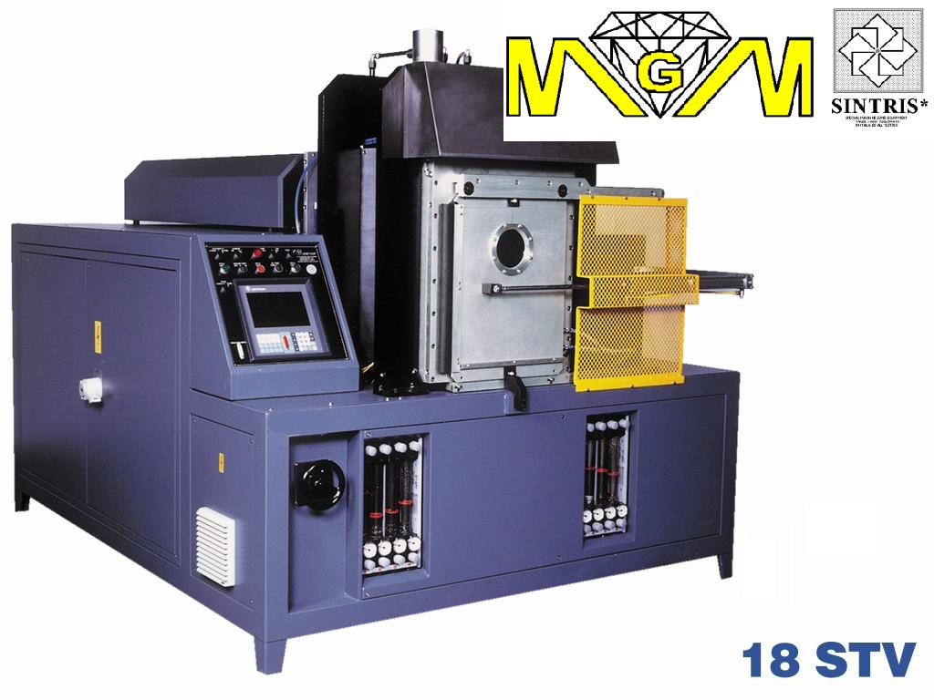

*AUTOMATIC SINTERING MACHINE MOD. 18STV, WITH CONTROLLED ATMOSPHERE, ONE STATION, 120Kva THREE-PHASE, 95 TON.
Main features
• Sintering machine suitable for the production of average and large size segment series, continuous rim blades, grinding wheels for glass and other diamond tools.
• Mould heating system for direct passing of direct current (Joule effect).
• Sintering with steel and graphite moulds.
• Sintering under controlled atmosphere by means of vacuum/inert gas programmable wash.
• Type K thermo-couple for operating temperatures up to 1000°C.
• Plates cooling, transformer and vacuum chamber with flow visualisation and water temperature.
• 120kVA three-phase transformer, (max. power supply is limited electronically to 210A) by switch for 3 different tensions between the electrodes(maximum power limit for heating).
• Controller program with cycles divisible into 12 steps. each step includes:
  ▪ temperature
  ▪ pressure
  ▪ max. power limit
  ▪ heating time
  ▪ holding time
• Compression force controlled electronically (loop system)
• Process data visualisation (set and real) and alarms.
Options
• Bar code for selecting sintering programs.
• Temperature control 350-1300°C by infra-red rays pyrometer
• Type R thermo-couple for operating temperatures up to 1200°C.
• Additional control thermo-couples.
• Segment height control while sintering takes place (linear transducer on cylinder, resolution of 0,01mm)
• Minimum compression force reduction system (from 4200 to 2400kg).
• Data acquisition system on external PC.
• Electrodes in graphite and amorphous carbon.
• Graphite plates.
• Graphite moulds.
• Aluminium frames.
• Prearrangement for modem installation for remote assistance.
Technical data
• Max. sintering area | 180 cm² (850°C 350kg/cm²)
• Power supply | 380 / 400V 3phs 50Hz
• Max. power consumption | 120 kVA (210 A)
• Transformer | 120 kVA trifase
• Compression force (adjustable) | 4200 - 95000 kg
• Electrode dimensions | 225 x 225x60(h)mm
• Plate dimensions | 400 x 400x60(h)mm
• Aluminium frames dimensions | 238 x 188mm
• Max. mould height | 175mm
• Gas consumption | 15 – 25 l/min N₂/Ar₂ (max. 5% H₂)
• Air consumption (filtered) | 2 l/min 6 bar
• Industrial water consumption (approx.) | 80 - 100 l/min 2–6 bar 10-20°C
• Colour | Choice
• Overall size (approx.) | 2050x2600x2100(h) mm
• Weight (approx.) | 3500 kg

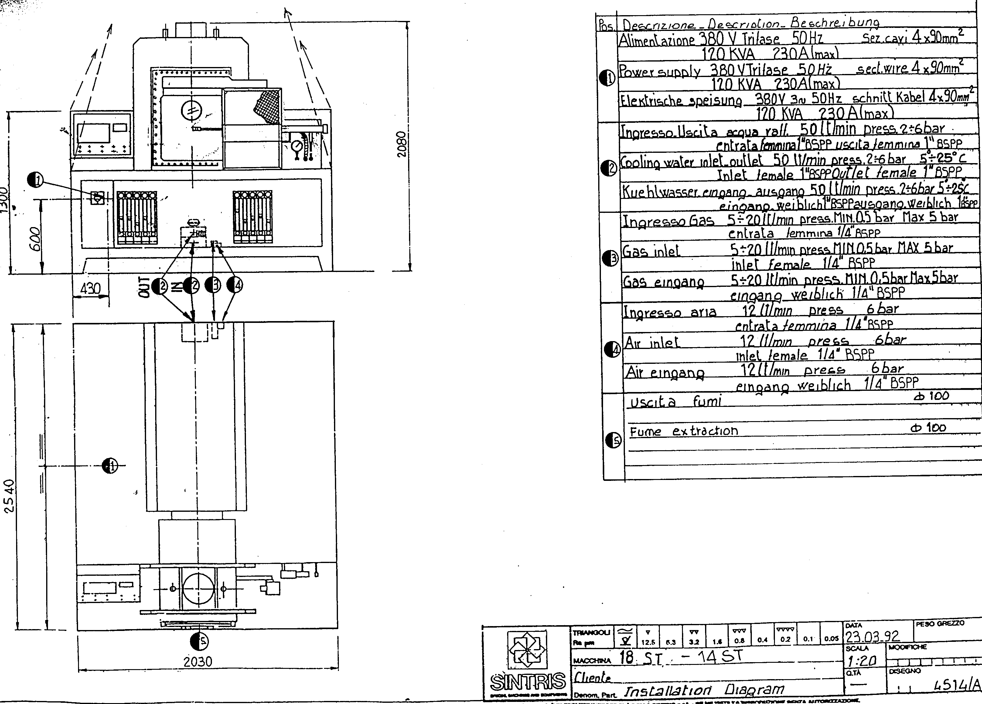

* MGM reserve itself the right to change the characteristics described in this document without previous notice.

