*AUTOMATIC SINTERING MACHINE mod. 10STV, WITH CONTROLLED ATMOSPHERE, 1 STATION 60Kva MONOPHASE, 26TON.
Main Features
• Sintering machine suitable for producing segments and small series of diamond tools.
• Mould heating system for direct passing of alternate current.(Joule effect)
• Sintering with graphite moulds.
• Sintering under controlled atmosphere by means of vacuum/inert gas programmable wash.
• K – type thermo-couples for operating temperatures of up to 1000°c.
• Cooling plates, transformer and vacuum chamber with flow visualisation and water temperature.
• 60 kVA Monophase transformer, (maximum power is limited electronically to 165A) by switch for 5 different tensions between the electrodes (maximum power limit for heating).
• Controller program with cycles divisible into 12 steps. Each step includes:
  ▪ temperature
  ▪ pressure
  ▪ max. power limit
  ▪ heating time
  ▪ holding time
• Compression force controlled electronically (loop system)
• Process data visualisation (set and real) and alarms.
• Machine complies with EEC regulations.
Options
• Temperature control by means of optical pyrometer 350 – 1300°C.
• Segment height control while sintering takes place (linear transducer on cylinder, resolution of 0,01mm)
• Data acquisition system on external PC.
• Regenerative system for the reduction of minimum compression force (from 1700 to 700kg).
• Electrodes in graphite and amorphous carbon.
• Aluminium frames.
• Graphite plates.
• Graphite moulds.
• Prearrangement for modem installation for remote assistance.
Technical data
• Max. sintering area | 60 cm² (850°C; 350kg/cm²)
• Power supply | 380 / 400V 3phs 50Hz
• Max. power consumption | 60 kVA (165 A)
• Transformer | 60 kVA
• Compression force (adjustable) | 1700 - 26000 kg
• Electrode dimensions | 140 x 140x60(h)mm
• Plate dimensions | 250 x 250x60(h)mm
• Aluminium frames dimensions | 168 x 148mm
• Max. mould height | 135mm
• Controller | PLC Siemens S5
• Gas consumption | 5 – 20 l/min N₂/Ar₂ (max. 5% H₂)
• Air consumption (filtered) | 2 l/min 6 bar
• Industrial water consumption | 40 - 50 l/min 2–6 bar
• Colour | Choice
• Overall size (approx.) | 1700x1700x2100(h) mm
• Weight (approx.) | 2000 kg

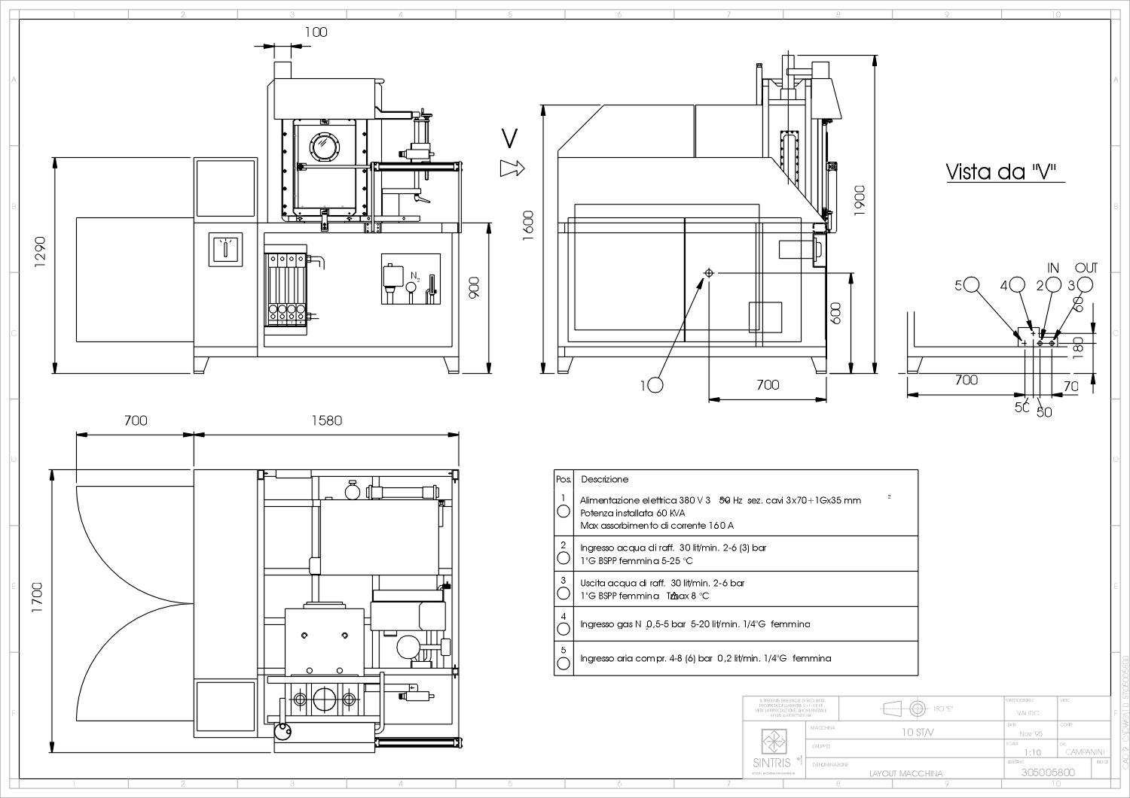

* MGM reserve itself the right to change the characteristics described in this document without previous notice.

